Beta Reader Mini-Round for ‘Three Year Old Child Developmental Map’
Thank you for participating in this beta reader round! This is a mini-round. It is for one chapter only of Misbehavior is Growth: An Observant Parent’s Guide to Three Year Olds. I am very excited to present the following. It will be offered for free on my Observant Mom website, so feel free to share it. It is a “Developmental Map” for the mental development of a three year old. I document the age-related “stages” children go through. It’s the times children fall apart, but this is because new mental abilities are on their way. I document the kind of behaviors you see during the irritable period of this and what new abilities are seen, for each developmental milestone. The summaries of this can be found on my website, www.theobservantmom.com. The following Developmental Map is a summary of those summaries. It is a high level overview, showing how one skill flows into the other. It ends with visual maps, of a child representing each milestone, over a timeline for age 3.
What I especially noted about age 3 is how much their famous wild imaginations, the monsters they see in their closet, seemed to aid in their very mental development. Thus, for this developmental map, I map their new abilities at each milestone to those imaginations. I take note of how they are related and how their new imaginations might aid in their growth. I also include, “What This Means”: what this means for you as a parent. Truly, there is more to them than meets our eye. If we can understand this, we can navigate these sometimes rocky years all the better.
What To Do
To participate in this beta reader round, you can do 1 of 2 things or both. You can either insert comments into this document and send them to me and/or complete a form, telling me what you thought.
The Form
Other than collecting your name and email, the feedback form only has 5 questions. To fill out the form, click this link: Developmental Map Feedback Form. Your responses will not be used in any way, except to improve the quality of the work.
Comments
To insert comments please go to “Insert -> Comment.” This allows me to click, “Next, next, next,” as I peruse the comments, so I don’t miss any. Send it back to me at helloamber@gmail.com. Alternatively, simply sending me an email with some comments is also fine.
I value your frank feedback. I am especially interested in knowing if this information is useful to you, as a parent. Then I want to know if the information is clearly presented. Is it confusing at all? Do your eyes blur over? Does it hold your attention? Do you want more examples? Note anywhere something is confusing or off. Tell me your honest gut feel.
This is only one chapter in the book, plus some charts. I am asking for a somewhat rapid response. Please send your responses to me by the end of the week, September 5, 2020. I can make some exceptions if there is a sincere desire to finish it but some life issues are in the way, but I am looking to proofread this book later this month and have the beta reader round for the entire book ready by the end of October.
I really, really appreciate your interest and time! Please hit me up, helloamber@gmail.com, with any questions whatsoever.
Thank you!
Amber

Three Year Old Child Developmental Map
When I look at a three year old child’s development, I am fascinated. As I did this work, it became clear to me that a three year old’s famous wild imaginations were linked to their new abilities. For instance, at around 3 years, 2 months, when can reliably hold on to information over about one day’s time, they start to have visions and nightmares. It made sense to me that these skills were linked. What is a memory except something imagined in your mind? Hence, when their mind is capable of vividly remembering something from yesterday, they also can conjure up the image of the bad guy they saw in a movie once.
I struggled and fought to understand how a three year old truly sees the world. In their early 3s, children think they can bring entire rooms to themselves magically. In their mid 3s, they think they can shrink into their toy trains. What is going on? These are children who, in their late 2s, can know how to get to the grocery store. Why are they so wildly fantastical in their 3s? Do they not see the 3-D world in the stable way that we adults do? Is it a fuzzy blur to them? Does their brain development cause them to “regress”?
I plotted the highlights of each milestone to get a better picture. Each milestone is a time when children fall apart—a clue that something is going on in internally—but which results in new mental abilities. I was especially interested in how a three year old’s wild imaginations matched to their new abilities. So, I mapped, for each milestone, their new abilities and the kind of new fantastical thoughts they had. I read this mapping back to myself, over and over, which read as a story, marveling each time at both the insights I could form from it and at child development itself.
My conclusion is that three year olds still see the world as an infant does: they expect their primary caregiver to do everything for them. In the same way that infants expect milk to magically arrive at their lips when hungry, (young) three year olds expect that they can magically bring ceiling fans to them. It’s not that they can’t see reality straight. It’s that this is a fun thing to think. If you spin a child at 3 in a chair and ask them if they are spinning or the room is spinning, they say it’s the room spinning. It’s important to understand that this truly is their perspective still. The world is a bit of a whir to them—but a fun whir.
Truly “playfulness” describes us humans and our development. Really, it’s as if nature consistently gives children an overabundance of a skill, which they play around with at first in a fun and fantastical way. They then soon refine their new development into a practical skill. When they realize they can do things in unconventional ways (Milestone 4A: Unconventional Application of Principles), they do, and just for the fun of it. Very shortly after, in Milestone 4B: Persistent Application of Principles, they start to insist that abstract ideas apply correctly to reality. Thus, their previous fantasy play becomes practical. When they think they can fit into a toy train, they play around with it. They soon start to realize the subtle shades of differences in a 3-D space, as they realize doors are open at a particular angle or they are exactly on the sixth step. It’s not just that they realize these things. It’s that they realize it also helps them size up and navigate the world. And “navigation” describes the first set of Three Year Old Milestones well.
This fantastical thinking, however, can cause problems. However, it only really causes problems because of a modern world. Ancient children didn’t watch scary movies. They never inconveniently imagined a bad guy kidnapping a child because they saw it in a movie. They never had to worry about going down a bathtub drain. Truly this work proves: modern life scares the crap out of children.
My other major conclusion in studying a three year old’s development is how much imagination plays a role in their development. What I concluded is that their reasoning capability (including creativity) is based on the amount of data they can hold mentally, and the amount of data they can hold mentally is based on how much they can imagine. The formula in child development is Imagination = Data = Reason. That’s as simple as I can get it.
And the reverse of it is true. If they are incapable of recalling relevant data, they are incapable of making “reasonable” decisions. They quite simply won’t care about your explanations when they are flooded by their own fears, expectations, and desires, which is all their current reasoning capacity allows. They are not capable of holding on to something peripheral to their current reality. They need data recollection to do that, and they don’t have it. What seems so obvious and real to us is not to them. The monsters they see are real. The fears they have, say of going down a bathtub drain, are the most vivid, lucid thing in their reality at the time. It is how they currently see the world. Expect and prepare for this. As I will say a million times: rational communication with young children is entirely overrated.
1-2-3-4 Progression
I wondered how three years old differed from two year olds. In the first half of 3, children get good at making educated guesses, recalling data, applying abstract ideas to reality, and navigating their way around in a 2-D then 3-D world. I see them as a bit like a rat in a maze trying to figure their way around. I wondered what the difference between age 2 and 3 was, as there is some recollection of data, imagination, and navigational skills at 2.
The best way I can describe it is to imagine their perceptual understanding as like a theater to them—a sort of play they are watching. At age 2, they get good at seeing the background set of the theater: the stuff that stays permanently. At age 3, they see the actors moving fluidly about. At 2, they can remember things that routinely happen: trips to the grocery store, to grandma’s, and things that made a big impression on them, such as Christmas morning. At 3, they get much better at in-the-moment, fluid movement.
I think of the first six months of 3 as the “1-2-3-4 progression” of child development. They roughly navigate their way across 1-dimension in space, then 2, then 3, then the fourth: extended time. When children just turn 3, they can plan and guess about one event going forward (Milestone 1: Speculation). Then, they the enter “2” in the 1-2-3-4 progression. They can plan among several options and are able to pivot (before they could not). They get really good at making navigational decisions in the width and depth of their current reality, i.e. an area, a 2-D space (Milestone 6: Strategic Thinking). It’s as if Mother Nature then causes a tremendous mental perception about 3-D space itself, entering the “3” of the 1-2-3-4 progression (Milestone 7: Specific Thought). It’s wild at first: they think large objects can fit into small toy trains. But they then start to see the shades of this 3-D space—and, more importantly, how they can use them to navigate. They then get good at not just the 3-D space but the 3-D space over time (Milestone 9A: Deductive Reasoning Across Time). They are capable of many mental manipulations at this one, as they weigh and consider the massive amount of knowledge they have. They are at the “4” of the 1-2-3-4 progression. This happens from the age of 3 until 3-1/2.
A “Periscope”: Data Driven Decisions
In the second half of 3, they start to categorize and size up the world, intellectually, as to, again, navigate in it. I describe it as if they develop a “periscope.” They think and plan before acting, and this “periscope” gets increasingly more complex. The periscope grows in complexity, as they can retain more data sets in their mind.
This periscope first develops when they say, “Mom! Go to the page of the book that has TWO trolls on it!” It’s not just that they identify the two trolls on the page. They use their categorization of this to help them navigate around: go to that page with the 2 trolls on it.
The amount of knowledge they can hold onto explodes in the late threes. They not only have knowledge sets, they can compare them. This is the fertile soil in which creativity grows. They take one idea from something and put it with another idea of something and come up with something altogether new. As they develop big knowledge sets AND compare them to each other, they start to think outside the box with if/then logic. They lose rinse, wash, repeat patterns. I described it as if they were a rat in a maze earlier, but now they smash the maze altogether. They think about what they are doing before doing it—indeed, they have a “periscope.”
In their very late 3s, they persist in their thinking. They can simultaneously hold on to two ideas at once, without losing one or the other. They compare these ideas. This is Milestone 11 (Two Alternatives). Then at the final milestone at three, Milestone 12 (Rules Leveraging), they can persist in holding on to knowledge and many technical details. They have a fully functioning periscope that can handle many mental variables and can figure out, say, when to appropriately cross the street. It is then they start to really take over major aspects of their life, launching them into the age of 4: an age of “superhero” thinking.
Growing Sense of Self and Heroism
There is also a growth of a sense of “self” and “heroism” in the 3s. I define heroism as an ability to change the environment positively. I define self as an understanding of who one is and what they are capable of. For a three year old, these things are correlated but different. It’s possible, especially at age three, to think change can be enacted without thinking you personally should do it. A sense of “self” relates to an understanding of who you are—with what you can do as one component in that. This grows in over age 3. I argue that core personality integration is the most important development at age 3.
The kind of imaginations, including nightmares, that they have, reveals the growth in self and heroism in fascinating ways. I plotted the progression of this, as I will detail below. I summarize it here:
The Progression of A Three Year Old’s Sense of Self and Heroism
- When they just turn 3, they realize they can “just pretend.” Previously, at 2, if they were dressed up as Snow White, they thought they were Snow White. If you think you can magically turn into someone by simply getting dressed up, you have no true sense of self. Now they realize they are “just pretending.” This is the first detachment from their previous thinking, in which all of life was “permanent”—unmoving, tethered. They are now an “actor” on the stage. It is a first sense of a conscious self, as deliberately chosen (Milestone 1).
- At 3 years, 1 month, they think rooms can magically come to them. They think things go on forever, such as you were going to fly into the road without stopping at a traffic light. They see sharks in the ceiling or dogs in the rug. Things move around in their reality now—whereas before everything was more permanent—but those things just randomly float. It’s slippery to them and even scary. There is little sense of “heroism” now if objects just float around. However, their own fear will still likely cause them to order you to stop at a traffic light (Milestone 3).
- At 3 years, 3 months, they think that someone can (and must) magically “boom” or “blast” cars out of the way while you are stuck in traffic. There is a growing sense of heroism here, control over reality, but without a self. They recognize some force needs to be applied to move the cars—a big thing to do, indeed—but they don’t necessarily put themselves in the role as the one to do it. An increase in heroism but not self. This comes soon enough. (Milestone 6A)
- Also at 3 years, 3months, in their fantasy play, they might drive a boat and crash it into the shore. There is heroism in this fantasy, but it’s just fantasy. What they do in reality and fantasy are still yet to be merged. And this milestone is about moving objects closer or further away. The fantasy play of a boat crashing into a shore is about movement across a space, which in and of itself is somewhat the very essence of heroism (movement/change) (Milestone 6A).
- At 3 years, 4 months, they develop more of a sense of “self.” However, it’s magical in nature and errant in what it thinks it can do. If they are separated from you, they think, “I can get superpowers to get to Mommy!” It’s magical, but they are now in the role of the one doing it. They are also off in what they think they can cause. They overestimate what they can do, causing them to be both overly ambitious and hard on themselves and over ambitious. They are overly ambitious: they think they can reach up and grab the ceiling fan. They are hard on themselves: they might apologize to someone who is crying, even though they aren’t the cause, and even though no one anywhere is blaming them. They have a thwarted view of what they can cause. Interestingly, a sense of shame and a sense of self go hand in hand. If you have the power to act, you can make things go positively (resulting in pride) or negatively (resulting in shame) (Milestone 6B).
- In the next milestone, however, just after 3 years, 4 months, they start to get practical. They don’t command superpowers to get to you; they use string to try to bridge the space between two objects. They might have nightmares where their brother was kidnapped by a dinosaur and they have to go find him. This is still fantastical but saving your brother from a dinosaur is as heroic as it gets (Milestone 7).
- At 3 years, 7 months, they imagine big, somewhat realistic, heroic things, but which they are again fantastical about. They might imagine that they are going to build a wider road, to fix traffic problems. Imaginary people are going to help them do this. It’s still a bit fantastical, but fixing a road is more reality-bound than saving their brother from dinosaurs. They also have a strong personality at this one; a strong sense of self. They are cheeky and very fluid in responding to their environment. They haven’t identified their own personality yet: that’s next. For now, they just happily are. (Milestone 9B).
- At around 3 years, 8 months, they develop a very solid sense of self. They say, “I am good, because ____” I am funny, because I make my mom laugh. I am kind, because I treat my sister nicely. They have conscious reasons as to what their good (and bad) traits. I consider this to be “core personality integration,” and I see it as a major milestone (Milestone 10B).
- Soon after this they might have dreams in which they do something heroic, such as finally riding their bike. This is self and heroism integrated. It is something entirely real that they can achieve! (Milestone 10C)
- In the very late 3s, their dreams seem to become pleasant. They may laugh in their sleep. I believe their sleep can now greatly aid as they learn new skills, of which they can work on day after day in a more long-term way. (Milestone 12)
Fascinated yet? It’s in their imaginations that so much can be gleaned.
Three Year Old Child Developmental Map
And so here is the map. There is a text write up followed by a visual map. In the text write up I include four things at each milestone:
  - The Milestone Name with the dominant new skills
  - Their New Imaginations and how they relate to the new skills
  - “What This Means,” which gives some notes on what this means to you as a parent.
  - An icon, what used to be called a “clip art,” representing each milestone.
The icon is of a young girl who has an arrow coming from her as it grows in complexity over the 1-2-3-4 progression. This is until she reaches core personality integration. At this milestone, the arrow (or box) is lost and all of that skill development becomes automated. It is now just part of her. This arrow otherwise represents her navigational sense and how it grows.
Then I have a visual map, collecting up all of those icons and putting them over a timeline spanning the age 3. Hopefully this will allow you to see the high level picture and become engrossed in the enormity of their development.
The age listed at each is the age of the earliest possible start date of the milestone noticed so far.
Three Year Old Milestone 1: Speculation and Mental Sorting
2.11.3
“Navigation” truly marks the first set of milestones in the early to mid 3s. It’s not just that a child becomes aware of objects in their 3-D reality. It’s that they learn to move, specifically to move forward in that environment. To think of this growing navigational ability, imagine an arrow coming from the child. This arrow, their navigational sense, is going to grow in complexity.
In this one, there is only one arrow that goes in one direction. They can make one educated guess as to what’s happening next. Clouds are coming—it must be about to storm. We’re going to a park to see ducks—maybe we could feed them. They solve problems less by trial and error and more through deliberate action: they have on idea in their mind that they work towards. They also integrate knowledge at one level higher. They don’t just classify cars and trucks; they now classify “race cars” as opposed to cars that serve other functions.
They can recall past events, but typically only things that are part of their normal routine. Life is still a bit “permanent” in their eyes—what is around them is, always has been, always will be. However, at this one, this “permanent” nature starts to loosen. Sorting patterns, as seen at this one, in and of itself aids in recollection. How humans do better if they classify information as to remember it later rather than try to remember long lists of items. So, too, perhaps the constant sorting they do at this milestone helps them recollect more about their everyday life, as will be seen in the next milestone. Children at this age also realize when they are dressed up as a character, they are just pretending. Before they thought they were that character. This is the first break in their former “permanent” thinking—and a first step of a “self” as a conscious, chosen, deliberate thing.
We are in the “1” of the 1-2-3-4 progression. On the icon of the girl, there is one arrow—moving forward—coming from her.
New Imaginations
They wonder about where things “disappear” to. When they see the sun but then the van turns, where did the sun go? Our garbage can is gone—where did it go? This fits perfectly with a child who is making educated guesses.
Their sense of hearing and smelling increase. They are intensely interested in things they can hear but can’t see or what things smell like. Given they are interested in what they can’t see and yet their senses themselves grow, it’s as if their instincts and intuition themselves are forming.
They have a noticeably longer attention span. They can make up a play such as they and their parents cook something in the oven. They build more elaborate structures. They stick with their idea longer.
What This Means
They have one arrow going forward. They can’t pivot or change from anything but that arrow. They will not handle disappointment well, such as a cancelled event.
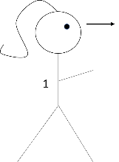
Three Year Old Milestone 2: Recollection
3.0.1
They can recall a lot more information about the day or previous day, but only if you are currently talking about it. They pick up on detail and nuance. They remember how their Dad said something in a way that is distinctive to their Dad. They have more information in their head.
They also verify things. Before they asked where the sun went if you turn in the van. If they can answer any such question for themselves, they go investigate.
For the icon, I have an arrow coming to the girl from behind. This arrow represents her greater data set of day-to-day things, which is soon going to fuel her ability to make flexible, planned, deliberate decisions.
New Imaginations
They have clear thoughts in their head, but they aren’t terribly forthcoming about it. They clearly become more lost in their thoughts, and for longer periods of time, as they mull over an idea. Or they work and work through something in their mind, muttering all the while, and then sputter out, “STEAMING DINOSAURS.” And laugh. Because it’s funny. They are trying so hard to recall what they know.
Their fantasy is no longer just plain silly as it was in their 2s. It’s much more focused and dedicated now; relevant to what’s going on. It’s still a bit murky and foggy to recall important information—indeed like steaming dinosaurs—but they can do it.
What This Means
They remain unable to handle disappointment well. They are trying to recall relevant information, which by nature is a very exact thing, and they struggle at first. As such, they can be quite rigid and stubborn. They lose this rigidity soon as they get good at recalling information and deliberately choosing courses of actions, even ones that are highly, um, unconventional—the next milestones.
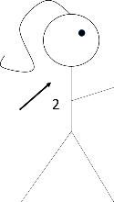
Three Year Old Milestone 3: Role Playing and Flexible, Short Term Planning
3.1.0
They deliberately try on different “roles.” They pretend they are someone or something else often. They might ask to cut their hair to look like their brother. They deliberately choose from several options now. They are, as they were aware of previously, just pretending.
They make better decisions. They accept the logic of, say, not changing their diaper at night—because it’s not dirty. They can now defy their normal routine—almost unheard of before. They need this extra recollection to make such sound decisions. They can also, as such, handle disappointment better. If something doesn’t go well, an explanation can be given and they are more accepting of it. They become notably more reasonable and they are often very polite, such as asking for permission before doing something.
As they have more information in their mind, and about daily happenings, they can be involved in short term planning. They can help make a grocery list. You’re out of milk, after all. They can pivot in their thoughts. They are flexible in going forward.
Therefore that “arrow” they have going forward can now pivot. The arrow coming from the girl can go forward, but can also change directions. Hence, the icon of an arrow that comes out then changes direction. We are now in the “2” of the 1-2-3-4 progression.
New Imaginations
They see things that aren’t there, like there are sharks in the floor or dogs on the ceiling. They might put their hands on their eyes as if they are scared to see what they are seeing. They think they can magically move entire rooms to themselves. They are sincerely worried moving objects might go on forever, such as a moving vehicle won’t stop when it needs to. Things just whir around in their mind: vans don’t stop at Stop signs, rooms can magically move to you, sharks randomly appear on the ceiling, etc.
Life now moves for them, in their imaginations, in their reasoning, and in complicated ways. But it seems to be slippery and even scary in how they perceive it.
What This Means
They insert themselves in other people’s decisions constantly. If you thought the van were about to fly off the road by magic, you would, too.
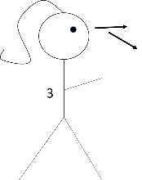
Three Year Old Milestone 4A: Unconventional Application of Principles
3.1.2
They do highly unconventional things for the sake of it. They might put both legs in one pant leg and walk around like that. Or try to wash their hands and feet. They try to help get everyone to the van, by pushing their infant sister—who was in a car seat. Before, they could agree that more than one solution could be a possibility. Now they try them out, with some creative twists. It can be quite maddening—or cute—it depends on both the situation and one’s perspective. You will undoubtedly notice this milestone.
They now evaluate their own ideas. They might announce they have a “great idea!” Before, they could pivot in the kind of decisions they made. They became flexible. Now they become aware of those flexible, deliberate planned decisions; that higher level awareness that comes with each milestone. They have a great idea about what course to take, as they look “above” the possible solutions that they generated, and pick one.
Imagine many different arrows going in different directions, entirely for the fun of it.
New Imaginations
They have longer and more intense dreams. They may have intense dreams where they laugh a lot or act out something, like flying. Or they seem to recite entire movies or TV shows as they sleep.
The “roles” they adopt are still fun and silly, but they apply to reality a bit more—though they are still silly and cheeky. Before they just pretended to be a bear for the fun of it. Now as they are looking for a toy they lost, they put on pretend binoculars.
What This Means
For you, their insistence on unconventional ways of doing things means you should pad some extra time before getting out of the door.
You should also monitor them a bit. Don’t leave them unattended with small children. They aren’t malicious, but they may try to “help” and this can go terribly.
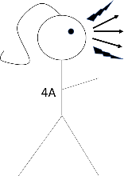
Three Year Old Milestone 4B: Persistent Application of Principles
3.2.0
They become very persistent in how abstract ideas apply to reality. If the rule is seatbelts are worn, it must be enforced. If you say you are making them a “3-waffle” sandwich, it now absolutely must have 3 waffles. They want to make their ideas a reality: they might demand you put a dress on, “so you can be beautiful.”
The forward moving arrow coming from them now becomes thicker, more aggressive, bolded, and aimed at the ground. I have 2 arrows in the icon to emphasize how attached to reality they are now. It’s as if it’s a further extension, almost a desperate reach, from their mind to make the abstract a reality. They must make their environment be “right.”
New Imaginations
Before, their fantastical play started to correlate to reality, but they were lighthearted and cheeky about it. Now, they lose a bit of their cheekiness and they get more aggressive. Rules are to be followed; what is said must be made true in reality.
What This Means
You will have a child on your hands who might genuinely help situations by calming their sibling down. Or alternatively, you might have a child who enflames situations as they order everyone to be quiet or do what’s “right.” They might, say, order their sibling to buckle their seatbelt.
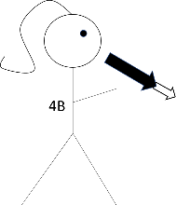
Three Year Old Milestone 5: Intentional Imaging
3.2.2
Intentional Imaging means they can see “something” where there is nothing at all. They conjure up images intentionally. Before, in their fantasy play, something represented their imaginations, such as a block was a “rock.” Now, they can now point to nothing at all and say it’s something, such as rocks are in a place where there is just empty space. Or, they hand you nothing at all and say it is a certain character.
I believe this new skill aids many other skills. For instance, at the last milestone, they insisted abstract ideas be applied faithfully to reality. Now, they identify mismatches between abstract ideas and reality. They recognize when someone else made a mistake or is “just joking.” I believe this ability to conjure up an image intentionally plays a role. They can imagine what is “right” and compare it to current reality—and current reality does not match. They might play around with lies because of this, as lies are funny and fun to them.
They now persistently notice everything around them. They “eavesdrop” constantly. They take note of all the details of what is around them, too. They have a running commentary as they go through a store, “Look! A chair! A desk! Wow!” They rattle off all the details of their favorite story. Their drawings get more detailed; perhaps because they remember the details of what they are drawing better.
They grow in how long they can reliably hold on to information. They can hold on to ideas, imagination, principles, and its relevance over about one day’s time.
Their ability to handle the abstract gets better. They fight now over what rule itself should be applied: should you share or take turns? They get diplomatic about conflict resolution. Instead of getting mad, they compose themselves and politely confront someone, “I am disappointed that you destroyed my creation.” They can pick courses of action based on verbal explanations alone. Will you wash your hands? If so, you can help me bake a cake.
The arrow coming from the girl is now highly persistent. It, with its own intentional ideas of things, persists. It frequently touches down to the ground and comes back to headquarters to verify, re-verify, and decide how to act. It also goes backwards, representing their better independent retention of facts over one day’s time. To represent its persistence, I have a dark arrow going back and forth from the icon of the girl, which has arrows that touch down to the ground and come back.
New Imaginations
This one is definitively marked by nightmares and wild imaginations. They might fear bad guys at night or monsters in their closet. They might wake up terrified. Unless they aren’t talking much yet, they can describe the dreams they had vividly.
I believe this shows how much their memory is growing. As they retain more information, unfortunately, some of that shows up for them at inopportune times. They “see” a “bad guy” standing right in their room, because they saw something similar in a movie. Or it shows up in their dreams. Or they are worried a monster is in their closet. This is just like how they can “see” rocks in an empty corner of a room.
I believe their imagination and memory are linked. What is memory but imagining a past event? At this one, they start to remember more across time. They remember things more reliably over about one day’s time. As such they “see” it in places. These nightmares are critical, in my estimation, to their mental growth. Dreams such as these are also critical in being able to see patterns over time, which grows enormously in the next milestones.
They also like to linger and look at things. They might erroneously say they “can’t see” something when it’s right in front of them. Or they get upset they can’t see their dad, who is driving in the car in front of you. They have to see things now.
What This Means
You may be dealing with a child with gripping nightmares and/or things they see in their closet or bedroom. Please try to remember that the imaginations they see really are real to them.
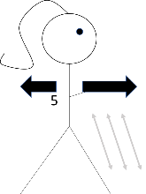
Three Year Old Milestone 6A: Moves Things Together or Apart
3.3.0
They are intensely interested in moving objects to them or going to places. How do you get to the cookie store? They love to push their trains together or introduce two people who just met each other. If given the opportunity, they are almost certain to put two figurines together in a kiss. They also now (seem to) understand, as seen in their play, that to see something, a person’s eyes have to be looking in a particular direction. If you asked them about this when they just turned 3, they got it wrong.
They remember more across time too and with richer detail. They can recite everything that happened that day as well as anticipate many events in the future.
As is usual of their development, the new development first shows up in a fun way before turning into a practical skill. They play around with the idea of moving objects closer to each other at this one. In the next milestone, they get good at moving around in a 2-D area in a practical way, even upon encountering it for the first time.
Imagine that arrow pushing things away and bringing things closer, across any given 2-D line of space. Right now, it’s just fantastical, wild, and for the fun of it.
New Imaginations
Their imaginations get bigger and they do more powerful things. A big blanket might be an “elephant.” Cars in front of you are in the way and need to magically move out of your way. They have a big imagination about things that are far away but could be closer, such as they are steering a boat and crash it into a shore.
While they are still fantastical, in thinking that cars can magically move, now they are thinking about movement itself. The car needs to move, darn it. They don’t quite put themselves in the role of being the ones to do it. But it’s no longer that things can magically just drift around. We see a bit of growing heroism now, although not as much “self.” They recognize the cars need an application of some force to be moved, but they don’t put themselves in the role of doing this just yet.
In previous milestones, they thought they could bring ceiling fans to themselves. It’s as if they realize this isn’t the case at this one, although they are still likely to think this off and on. Truly, they don’t see the world in the same stable, 3-D way that adults do; at least not in the same way where we firmly know we must act “rationally” to attain our goals.
What This Means
They might want to go to places just to see how to get there, such as a cookie store. They might boss you around as to where you are allowed to sit or look.
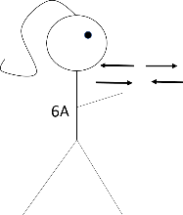
Three Year Old Milestone 6B: Strategic Thinking
3.3.2
They get really good at moving around in an area, even after encountering it for the first time. They might go to a museum for the first time ever, and they quickly learn their way around. They are likely to want to run all over, figuring it out. They also learn things on-the-spot better, such as perhaps a hands-on exhibit they just encountered for the first time at the museum.
They are methodical in solving future problems at this one. They also remember details from the past on their own. Having this persistence of memory is correlated to being able to persistently solve a future problem. If they are, say, trying to figure out which X in a set of Y things is missing, they have to remember all of the things they’ve identified in Y so far as they figure out X.
Their memory over time grows to about one week. They, as such, notice patterns that happens on a weekly basis, maybe that you always go to a certain restaurant.
They have now fully mastered 2-D space: the width and the depth of what’s around them, the area. That arrow that comes from the girl can now go all around in zigzag patterns and circles, but which eventually make sense of itself.
And Mother Nature is not lazy. At the very next milestone, they will develop a (fantastical, at first) heightened awareness of 3-D space, entering the “3” in the 1-2-3-4 progression.
New Imaginations
Their big imaginations become more heroic and with more self: they are going to get “powers” to get themselves to Mommy (when she’s far away). They don’t just “boom hurricanes away” now. They have a more fully realized “self” now. They get superpowers to mommy. It’s still fantastical, with “superpowers,” but they are the ones doing it, and with some tool: superpowers.
They also might blame themselves for things going wrong that they didn’t do. They might apologize profusely to a baby that is crying, even though they are not the cause of the baby crying and even though no one is blaming them. They also overestimate what they think they can do. They might think they can reach up and grab an airplane. Heroic, with self—but a bit off. They become refined in what they can do in the very next milestone.
They can also remember robust things totally on their own from days prior, without you ever having talked about it.
What This Means
They get around better in a space, but they don’t see shades of this yet. When you go to a restaurant and they see it from the road, they might order you to stop then and there, because, after all, you’re basically there. Seeing shades of difference in a large 3-D space as they move around in it is the next milestone.
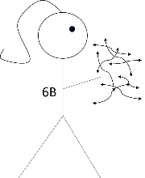
Three Year Old Milestone 7: Specific Thought
3.3.3
At beginning of this one, they show they think large objects can magically fit into small objects. It kicks off “3” in the 1-2-3-4 progression: mastery over a 3-D space.
Before they thought a ceiling fan could magically come to you. This is a fantastical thought over just one dimension: length between them and the ceiling fan. Now they think a large object can magically fit into a small one. The fantastical thought is now related to all three dimensions.
It’s as if nature gave them an overabundance of a skill that they then refine. They became aware that objects might fit into other objects, but they are way off at first. Then they see some of the shades of this. It’s as if nature gave them, not a wonky way of seeing things, but a huge imagination. This imagination is, for the most part, a delight. It’s fun to think you can shrink into a toy train. Their imagination in the 3s aren’t so much that they see things “wrong,” but in what they think they can do. They think they can magically move things around or shrink. Maybe it’s just silly fantasy play meant to act as an impetus to go out and try their hand at the world.
And they get much better about that at this one. They start to see the nuance of their 3-D surroundings. They get very specific (and stark) in describing things. They are on the SIXTH step. A bird is DEAD. They notice the exact angle their fork is at compared to their plate or how open a door is. It’s not just that they can see the specific nature of the world around them; they use it to think and navigate. They use this categorization to size up the world: they remember that page on a book had 2 of this or that and that’s how they describe it to you so you can find it easily.
They can build creative mental patterns now too, such as putting something in rainbow order or making up a poem, on the spot, about something that just happened. That they can hold on to mental variables will help them in the next milestones as they make much more deductive reasoning.
They also get more practical about trying to get things to themselves. Before they thought they could magically move rooms to them; then that they could get superpowers to do that; now they use string or other things to try to get things to them. This also starts a love of racing. They see clearly the space in between them and something and they want to be the first to get to everything.
The arrow coming out of the girl is going in all 3 directions, but broken up into mini-arrows. Those mini-arrows are now going to exactly where they want and stopping.
New Imaginations
They think, say, that their stuffed animal can fit into a tiny train.
In the last milestone, they put themselves in a more heroic role, bridging space between them and others in a practical way, such as by crashing a boat into a shore. The nightmares they have now reflect this new heroism. The nightmares might be something like a dinosaur kidnapped their brother and they need to find him. This is heroism defined. Going to help your brother after a dinosaur took them is as heroic as it gets!
They might also think monsters are chasing them. I never cease to be astonished by how scared children are that things chase them.
What This Means
For the most part, thinking you or your stuffed animal can fit in a tiny train or building is fun. However, given our modern world, it means they might be scared to death that they’ll go down the bathroom drain. Let’s pause here. Imagine feeling you were in a big pool of water and you might magically get sucked away. What would that feel like? Why does this happen to the child? Do you think you can reason with them that this is not the case?
Given their better understand of distance and movement, they may have a heightened fear of cars hitting them in parking lots. Neuroscientists might take especial interest at how the areas of the brain that don’t just cause, but govern, fear grow in through these milestones.

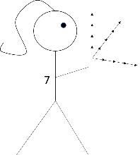
Milestones 8A, 8B, and 8C: Integrates Sets of Knowledge
3.4.1
They compare and integrate entire sets of knowledge. Before, they built creative mental patterns. Now it’s as if they have several “sticks” of creative patterns that they compare, do things with, and bash together. They notice for instance that animals sleep just like humans sleep. They integrate and mash these knowledge sets together. They might get parts of one game and use it for another game. They might fully integrate the sets of knowledge by assigning Red as 1, Orange as 2, etc., as they tie numerical order and rainbow order together. They start to compare themselves to other people, often other children, as well. With more to think about, they draw more deductive reasoning. They might see a person with their car window down and conclude the person may have wanted fresh air.
In 8B, they insert themselves into situations more. They play more with other children, and they even sometimes become destructive. They start to truly see other people as such, and they are judgmental about it. So-and-so is their best friend. Mom, you’re a great cook. Their house is really awesome.
Milestone 8B also begins the nuance they see the world in, which is so new and so nuanced, that it may give them decision paralysis and cause some great communication problems. They don’t have the language for what they see and want to do yet. If you have a child who becomes confused like this, it likely won’t let up until they are nearly 4.
In 8C, they insert themselves but they are more cautious and reflective about it. If they see you sleeping, they’ll back out of the room, “I am going to let mommy sleep.” They are more cautious: they pause and think before doing things. They may want to watch you do something first before they try. This growing reflection may bring with it the first subtle form of authentic shame, such as they quietly ask you to fix a toy they broke of their siblings.
Let’s imagine two arrows, differently patterned, coming from the child as they mix and match information with each other. They, at headquarters, can see both arrows and now make better decisions, as will explode in the next milestones. They are soon to get out of the “rat maze.”
New Imaginations
They still think they can shrink, that you can magically grab airplanes, or that their brother can spontaneously turn into a “bad guy.” However, they start to get more and more realistic about this. Towards the end of 8B, they don’t think they can go down a bathtub train, but that a smaller toy can (when it won’t).
They, however, think rules are forever. If you tell them not to go on the stairs, as you are cleaning them, they think they can never go up the stairs again. This is the first hint of the “4” in the 1-2-3-4 progression: mentally manipulating information over time.
This is also the first age that, I’ve found, that a child can spontaneously remember something from a few months ago, such as a big holiday or picking Grandma up from the airport. That arrow they have can now go quite a way forward and backward. Long term memory is forming. Again, we are, although only ever so slightly, in the “4” of the 1-2-3-4 progression.
What This Means
They are comparing entire knowledge sets together. Soon, they will be spurred to stop doing things in a rinse, wash, repeat way. I believe having several knowledge sets helps in this. They have more data in their mind to compare and contrast, spurring creativity, such to then better decide how to act.
That they still have crazy ideas of what could happen to them (magically shrink, etc.) and that they are now so cautious means they might get extra scared of new, overwhelming situations, especially in 8C. They are both fantastical and cautious. Hence, some issues.
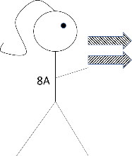
Three Year Old Milestone 9A: Deductive Reasoning Across Time
3.6.1
They hold on to information across time now AND they do some mental manipulations with it. They see a puddle and conclude it probably rained yesterday. On their own, they remember you are out of milk and offer to drink juice. They do mental math in their head, on their own initiative. They can not only compare but challenge sets of ideas, in cute ways. If dad says, “Diesel [the gas] came down in price,” they correct him, “No, Daddy, Diesel dropped the jobi logs.” This is from Thomas the Train; “Diesel” is a name of one of the characters, who did indeed drop jobi logs.
They are highly receptive to learning new skills, and they want to try their hand at everything, such as making their own toast or putting on their own seatbelt. They pick up on new words easily and repeat them back accurately. They persist longer in drawing or making a craft of their own choosing and design. They set up their own play now, such as by getting all necessary supplies or getting everything needed to put on a play that they thought of with you.
The arrow coming from them doesn’t just extend into space. It now has a fourth dimension: time. The arrow now persists across time and space, showing the 4 dimensions, and that they do mental manipulations are done across time.
New Imaginations
This is the first age where they might develop a semi-persistent fear such as “tigers are chasing me!” They worry about this, the same exact thing, day after day. It’s no longer “monsters.” It’s now tigers or snakes. It’s also not lost on me that they do mental manipulations with events over time at the same time their wild fantasies now persist day after day.
What This Means
As they remember more over time and recognize its significance, they also can get extremely overwhelmed by shame. They handily realize something they did yesterday did cause something to go poorly today.
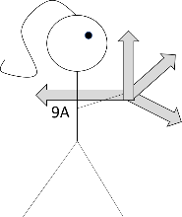
Three Year Old Milestone 9B: Enormous 3-D Imagination
3.7.0
They can create an enormous, vivid 3-D space in their mind. They can imagine outer space or being on the moon. They are no longer limited to their current reality: they can imagine something as big as current human knowledge allows.
They start to deal with conflicting requirements, such as they want you to sit in one place for one reason and another place for another reason, but they can’t satisfy both desires. Their sense of self has been growing, and their sense of others has been growing in a similar way, where they see another person has their own needs, problems, and personality. The natural conflict resolution of this starts to cause issues.
They are very, very fluid and in the moment now. They have a cheeky, robust personality. They are soon to identify their own personality. But for now, it’s simply there; simply present; they just are.
They are fully committed and passionate about the projects they work on. They obey what you ask for a longer amount of time, perhaps the entire rest of the day.
I imagine the symbolic representation of their situational awareness as graduating from arrows to a box, representing that they now live in a large 3-D world easily.
New Imaginations
They imagine big but realistic things. They might see a road is too narrow and imagine themselves building another lane with workers to help them. They are working in a realistic 3-D space now, and over time. They also start to develop imaginary “friends.” Except they aren’t “friends” yet. It’s just people that show up in their imaginations, such as workers who will help them build a road.
What This Means
That they are starting to deal with conflicting requirements can cause some issues. They continue to not be able to communicate the nuances of what they want, sometimes.
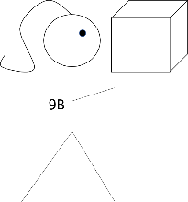
Three Year Old Milestone 10A: Enormous, Detailed Knowledge with If/Then Logic
3.7.2
They absorb and use knowledge with astounding speed and reliability. They have enormous data sets in their mind. They can remember all of the planets, know quite a bit about what certain types of animals eat, or take an interest in all of the details of a machine.
As they have so much knowledge and maneuver so handily, they start to doubt and break traditional routines. This causes better if/then logic. Is dad home? Because if not, there is no need to set out his breakfast plate. They may want a different breakfast than normal or refuse to do something the family does every week. They are just plain throwing their weight around, because they can.
It’s now a 3-D space that they work handily and fluidly in in. They have officially smashed the box. They see this full space chunked up into details. Hence, the box from them is now chunked up into smaller boxes. However, the details are still sometimes discrete and detached. Don’t worry. Mother Nature quickly makes up for holes like this. In the very next milestone, they’ll put these discrete pieces into an integrated whole.
New Imaginations
Nothing new to report, really. They are like a vacuum now, sucking up new knowledge and using it. They might ask curious questions, such as, “Does the sun run on electricity since it’s so bright?”
What This Means
They break traditional routines. If you’ve been giving them a bath every night at 7:30 since they were 6 months old, they might refuse to get in. Or they might refuse to go to that restaurant you go to every week.
They are still dealing with conflicting requirements and nuance. They sometimes can’t make up their mind about what they want and might enter into endless “do loops.” Or they might be unable to decide what exact place in the house they want to sit to put their shoes on. They can’t communicate what they exactly want either, such as “Put the TV show on but skip the introduction.” They have an enormous amount of knowledge in their head and its chunked up into details. It’s as if they see the details but can’t quite deal with them yet.
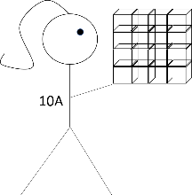
Three Year Old Milestone 10B: Thematic Thinking
3.8.1
They take all of this detailed, chunked up information and put it into an integrated whole. I consider this to be a major milestone with core personality integration at its core. They put together the pieces that make up them to develop a picture of themselves. They are a good person, because ____. They are funny, because they made mom laugh. They are responsible, because they helped you with the dishes. They can understand all of the technical details of something, say of a roller coaster, and then draw it out and explain it. Or whatever it is your child takes an especial interest in. Their art begins to really take shape as they design new things intentionally. They develop great precision with their hands, and love to get their hands on things: cutting things, using a hammer, etc.
They are highly socially perceptive now. They see the good and bad traits of others, just like they see of themselves. My favorite story at this milestone is when my daughter said, “WAH, Wah, wah,” to a waiter—because his joke fell flat.
I would drop both the arrows and the 3-D box now. They are, of course, there. But they have now mastered navigation and even 3-D space. It is automated now. You now have an integrated person whose core personality is becoming set in stone, who has strong footing, and is done being “in” and about to go “out.” They are, simply, a person. Hence, the icon: a beaming child. A child who is about to go do things.
New Imaginations
They now have elaborate plot lines in the imaginary threats they have. Hippopotamus are chasing them; black holes might suck them in; or a “light saber hit me and hurt me.” However, they take delight in these stories. They might have some fears, such as that snakes or dinosaurs are in their bed.
Their day-to-day play also has more of a plot line. Sometimes this means they might have a big fear of what might happen to them. They worry you might drop them off at a donation store. They might assure their stuffed animals that they will always take care of them. They might invite their toy cars to come to the playground with them.
What This Means
You still may be dealing with miscommunication errors. You might reassure them if you, say, go to a donation store, that you would never ever drop them off. Really a child at this age can be a delight.
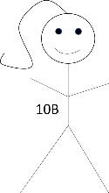
Three Year Old Milestone 10C: Intellectual Precision
3.9.0
They have been chunking up the world into bite sized pieces for some time now and getting quite confused about them, but now they see these details with precision. They can estimate that something takes a few seconds versus a few minutes. They measure things with a ruler. They notice things were a “close call!”
The icon is a girl with a pencil. They may not be drawing yet, but the pencil represents that they are much more precise in how they do things and they are in a more active role, now drawing things and making things happen. The pencil could also easily be thought of as a stick, a ruler, etc.
New Imaginations
What I found so interesting is that, after the last milestone of core personality integration, they have dreams about their very selves now, doing something heroic. They might dream they rode a bike—and they’ve been trying so hard to do this! They are fully in the heroic role now, as integrated with self. Not that things float around. Not that they pretend to be captain of a ship. Not that they get “superpowers.” They are doing something—something real!
What This Means
Their growing precision will get irritating and quick. If you say the sun shines on them without saying it “SOMETIMES” shines on them, prepare to be reprimanded.
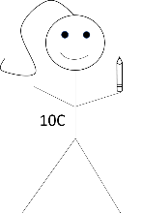

Milestone 11: Two Alternatives
3.9.1
They can now hold on to two thoughts simultaneously. They can persist in thinking that they are currently going north, but if they turned around, they would be going south. They weigh/contemplate two things, ideas, or people. They can be methodical about it. They might make two paper rockets and test each to see which goes higher. Or they might methodically test how to make things balance on a scale. Based on visual acumen alone, they can tell that a large thing will not fit into a small thing.
As they’ve been developing a sense of self, they have been developing a sense of others, too. They compare themselves to others often now. The comparisons seem petty: whose balloon is higher in the air? They really want to be the best now.
They come up with solutions that satisfy all. If they don’t want to go to the pool and you do, then YOU go. THEY are staying home. In fairness, it makes sense. But obviously you can’t leave a three year old at home alone. That part they aren’t so understanding of.
They are a bit like a dog with a bone. They persist in knowing what they want. They hate distractions along the way. They might be convinced you’ll get their order at the restaurant all wrong—before you are even there. They know they want to keep the TV on and any agreement to turning it off, such as letting them do it, is a bit of a trick. They are very stubborn at this one.
They generalize and make hypothesis now. Before it was, “Mom is not good at [x] and I am.” Now it’s, “Boys are good at [x] and girls aren’t.”
The icon is of a girl with two rockets, experimenting with which one goes higher.
New Imaginations
They might smile in their sleep, showing they are having pleasant dreams.
What This Means
They are extremely stubborn. They feel they have a good solution to satisfy you and them, and they don’t budge. They also persist despite distractions. So, again, they are very stubborn. They might insist on what they are going to do or, more likely, what they are not going to do.
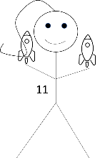
Milestone 12: Rules Leveraging
3.10.2
Before, they could handle two ideas in their head at once. Now, they can handle many, and in a way that they are all more fully integrated. They hold onto many variables at any one time to make a good decision: they “leverage” the “rules.” They can take in (almost) all factors necessary to intelligently cross a road: what cars are around and if they have their turning signals on.
They started to generalize in the last one and now they fully generalize. They fully understand what the rules are and usually comply. They’ll work the rules themselves to their advantage. If the rule is no candy, because it’s bad for you, then perhaps just one of something per day would be OK. Or if you have a book they like, if you have two of them, then surely they can have this one. I sometimes call this the “lawyer” milestone.
The icon is of a girl with a periscope. Truly, they are “scanning” now. They take in everything around them to make a good decision, as captain of the ship. They will advance the interest of their own “ship,” as in response to the new information they get.
New Imaginations
Nothing new to report.
What This Means
They feel confident in making decisions with complex variables. They might suddenly do such a thing, such as run into the road, because they felt they were safe to cross.
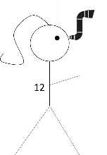
A Sneak Peek at Age Four
Four is an age of pushing the bounds. In the last three year old milestone, they developed a periscope to navigate a “ship.” At 4, they are going to be testing this very “ship.” The very first milestone is “Differentiating the Possible from the Impossible.” Age four remains highly fantastical until they go through a milestone where they realize they really can die. And then thing become really real to them. I look forward to telling that story, too.
Errors and Future Study
Of course, my mapping may be all wrong. Maybe I put too many patterns where patterns aren’t. Maybe things are out of alignment in how I linked them. But I hope by bringing more clarity and study to it, you notice more about your child.
And I hope that this spurs future study. I believe mapping young children’s wild imaginations to their abilities may be the clue needed to further understand their brain growth. It’s like a Rosetta Stone. It can translate one language to another: knowing what wild fantasies and even nightmares a child has can lead us to understand the exact areas of the brain that is growing. Combining neuroscience, behavioral patterns (this work), and daily pictures or sketches of a child’s changing head shape, one can get much more nuanced detail of what is forming and when. I hope to kick open the child development research door as to study it in detail. Child development research is like exploring space: it is both vast and nuanced.
And we’ll never be done exploring, ever.

Visual Maps
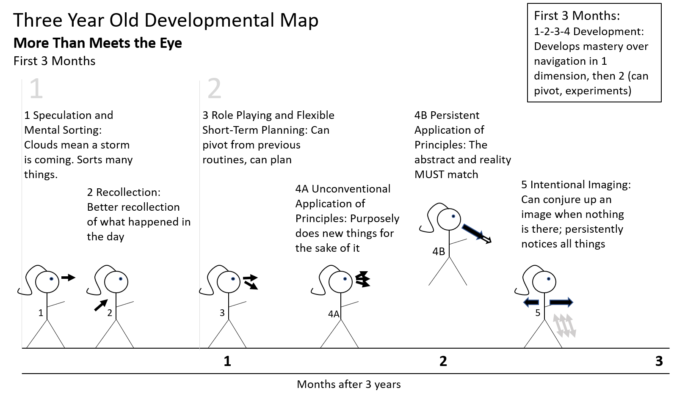

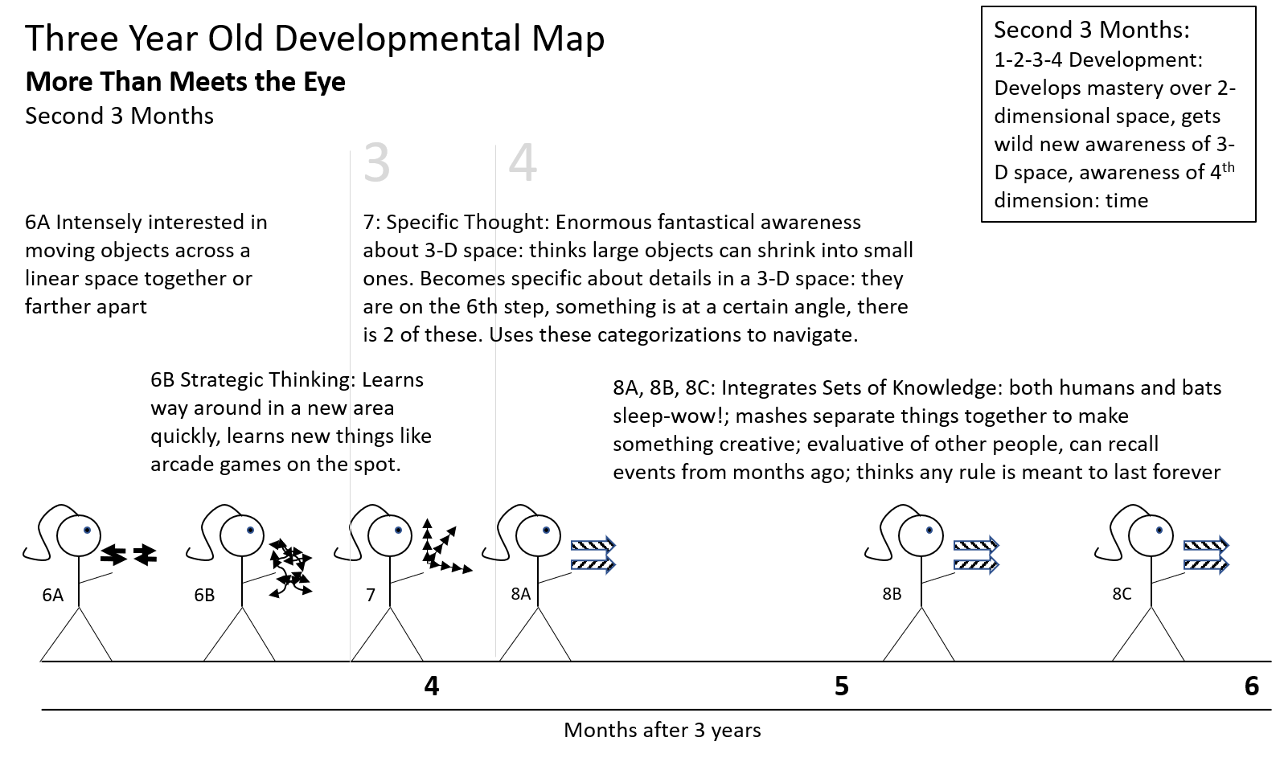
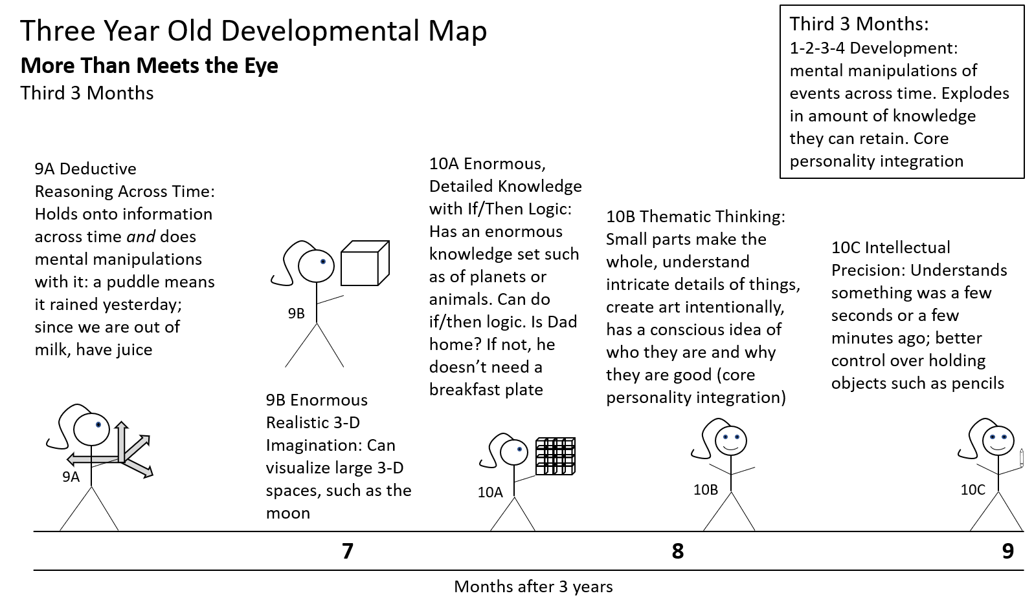
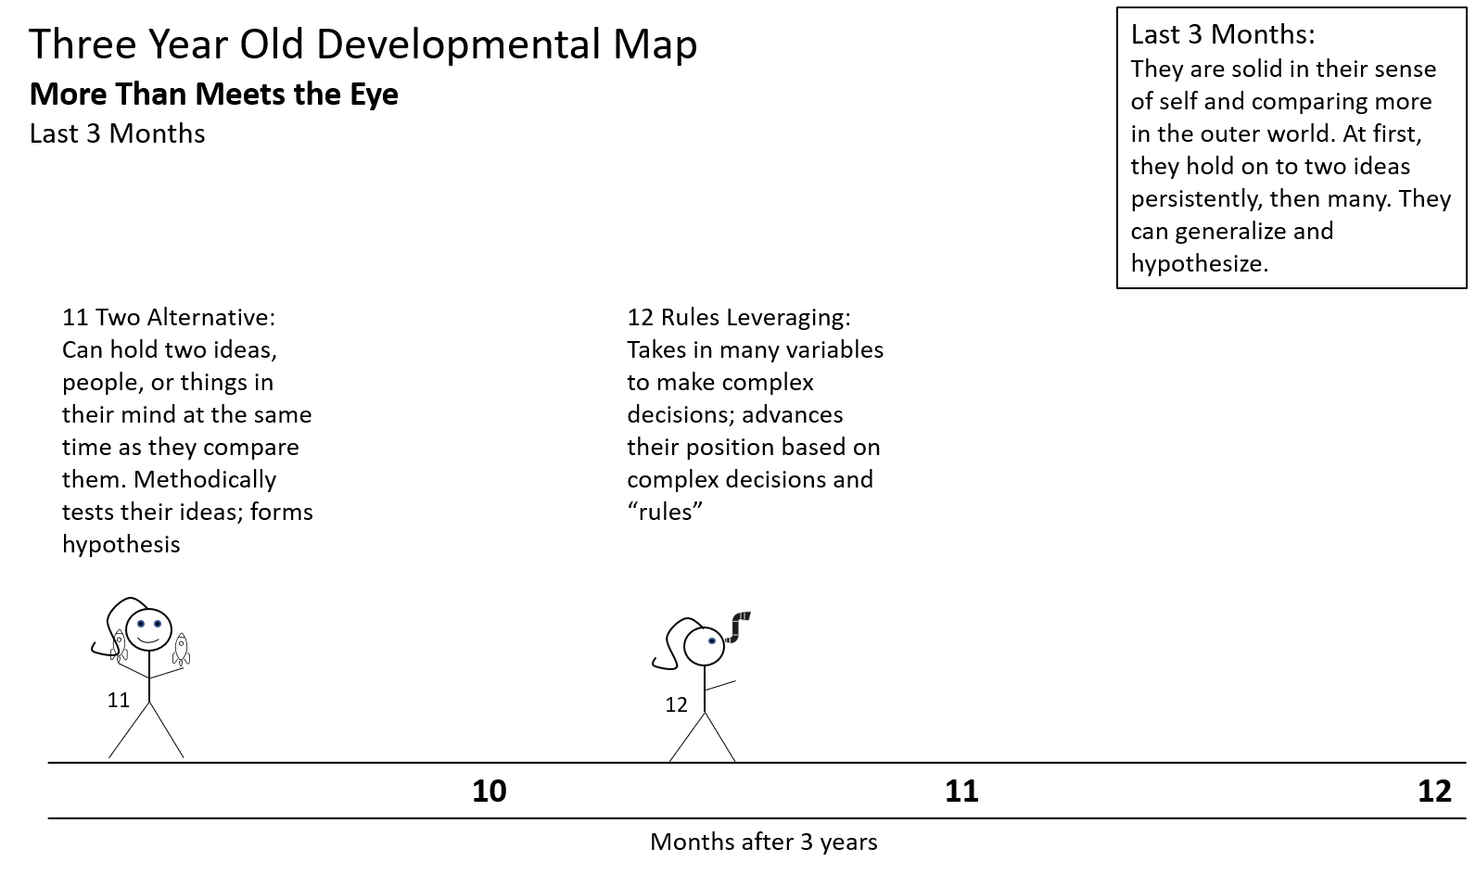
What This Means
As a three year old goes about their life, truly there is more than meets the eye. While they are defying us to get their pants on or won’t get in the bathtub, something much bigger is going on. It is here where we should live as parents.
###

